

**PRECISION AGRICULTURE AND THE ROLE OF AI AND ROBOTICS**

**Department of Computer Application, Lovely Professional University**

**Artificial Intelligence and intelligent systems.**

**Mahendra Velpula**

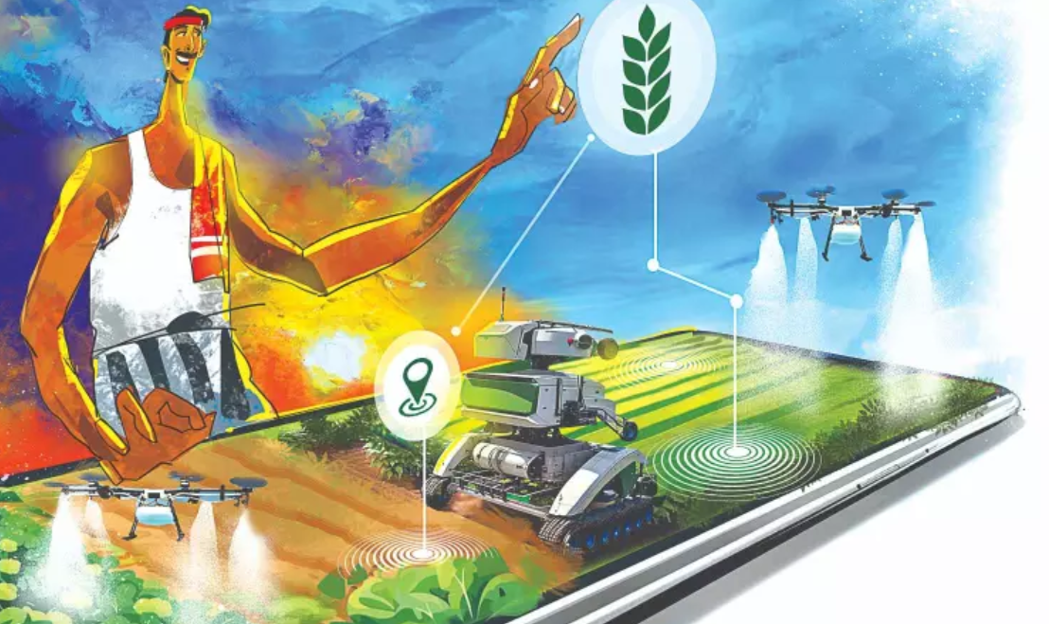

**ABSTRACT:**

In modern agriculture, various challenges like crop diseases, pests, water scarcity, and weed proliferation threaten crop health, leading to financial losses and environmental risks. To tackle these issues, precision agriculture has emerged as a game-changer, aiming to optimize resource use, boost crop yield, and minimize environmental harm. Artificial Intelligence (AI) and robotics have revolutionized precision agriculture, enabling data-driven decisions, automated farming tasks, and sustainable practices. By combining AI algorithms, advanced sensors, and robotic systems, real-time data collection, analysis, and targeted interventions become possible, promoting efficient resource management and better crop outcomes. This exploration of AI and robotics in precision agriculture delves into their applications, challenges, and benefits, shedding light on the technological advancements reshaping the future of farming.

**KEYWORDS:** Keywords: Precision farming, Artificial Intelligence (AI), robotic technology, data-informed decision-making, agritech, eco-friendly agriculture, robotic farming, intelligent agriculture.

**INTRODUCTION:**

In today's agricultural landscape, Precision Agriculture shines as a beacon of technological progress, tackling the urgent challenges of food production by merging Artificial Intelligence (AI) and Robotics. This chapter delves into the transformative collaboration of these disciplines, shedding light on how they are reshaping farming practices.

Precision Agriculture has emerged as a response to the complexities of feeding a burgeoning global population while conserving vital resources. AI analyzes a wealth of data sources, offering insights into soil health, weather patterns, and crop conditions, guiding decision-making with unparalleled accuracy. This fusion of AI with Robotics translates insights into practical solutions, automating tasks like planting, irrigation, and harvesting with remarkable precision. This chapter explores the foundational concepts, practical applications, and potential hurdles presented by this union, providing a glimpse into the future of sustainable and effective agriculture.

**1.LITERATURE REVIEW:**

**1.1 Concept of Precision Agriculture:**

Precision agriculture, also referred to as satellite farming or site-specific crop management (SSCM), represents the integration of modern information technology with traditional agricultural practices. This holistic approach to crop management aims to align the types and quantities of inputs with the specific needs of different zones within a field. While the concept itself is not new, recent technological advancements have made the practical implementation of precision agriculture feasible. Therefore, embracing these emerging technologies is seen as crucial for improving future agricultural productivity.

Unlike traditional methods that manage entire fields based on average conditions, which may not accurately represent every part of the field, precision farming recognizes the unique variations present within fields. This approach involves adapting management practices to account for these site-specific differences, thereby optimizing the use of resources. For example, in India, the prevalent method of soil fertilization is broadcasting, despite its inefficiency in delivering nutrients to crops. Despite the availability of more effective alternatives, this method persists, leading to increased variability. Precision agriculture offers a novel solution by adopting a comprehensive approach to address contemporary agricultural challenges, including the need to balance productivity goals with environmental considerations, as emphasized by Hakkim.

**1.2 Definition:**

Precision agriculture refers to the utilization of contemporary information technologies to acquire, process, and analyze diverse data from multiple sources, characterized by high spatial and temporal resolution. This comprehensive approach is employed for decision-making and operational purposes in managing crop production.

**1.3 Significance of Precision Agriculture:**

Precision agriculture offers a strategic approach to optimize food production by leveraging real-time data collection and comprehensive analysis of agricultural processes. By integrating various data points, including crop details, soil attributes, microclimatic conditions, and irrigation setups, precision agriculture facilitates informed decision-making. This data-driven approach enables farmers to tailor management practices according to specific zones within fields, maximizing resource utilization and crop yields.

The database utilized in Precision Agriculture typically encompasses a range of data points .

* Details about the crops including growth stage, health, and nutrient needs.
* Drone flying over a farm

  Description automatically generatedPhysical and chemical attributes of the soil such as depth, texture, nutrient levels, salinity, toxicity, temperature, and productivity potential.
* Microclimatic information for different seasons and daily changes, including canopy temperature, wind patterns, speed, and humidity.
* Conditions related to surface and sub-surface drainage.
* Information about irrigation setups, water availability, and the coordination of additional inputs.

**1.4 A Comparison between Precision Agriculture and Conventional Farming:**

Precision Agriculture involves partitioning the agricultural field into discrete "management zones" based on factors such as soil pH, yield rates, and pest prevalence, all of which impact crop productivity. Decision-making revolves around meeting the specific needs of each zone, utilizing Precision Agriculture tools like GPS and GIS to manage inputs within these designated areas. Conversely, traditional farming adopts a "whole field" approach, treating the entire expanse as homogeneous. Decisions are guided by overall field averages, leading to uniform distribution of inputs across the entire field. Precision Agriculture's advantage lies in its ability to allocate resources more efficiently by directing inputs to zones with higher economic potential, thereby maximizing returns for each input.

|  |  |  |
| --- | --- | --- |
| **Operations** | **Conventional farming** | **Precision agriculture** |
| Selecting an Optimal Site | Manually | Using drones and GPS |
| Soil Preparation | Adding chemicals based on previous experience | Using sensors like temperature sensor, Humidity Sensor, Volatile matter sensor etc |
| Field preparation  (Ploughing and planking) | Using tractors and bullocks | Agricultural robot for automatic ploughing |
| Seeding and planting | Manually using hand tools | Precision drills, Broadcast seeders, Seed drills, Air seeders |
| Watering | Drip Irrigation | Drip Irrigation using Internet of Things |
| Fertilizer and Pesticide application | Hand spray and manually | UAVs and UGVs, Sprayers, GPS, Smartphone Applications, and Remote sensing |
| Weed removal | Using hand tools | Blue River Technology and Naio Technologies Weeding Robot Oz |

**2. METHODOLOGY:**

**2.1 Precision Agriculture: Key Tools and Technological Advancements:**

Precision agriculture has undergone remarkable advancements in recent years, driven by the integration of cutting-edge tools and technologies aimed at optimizing agricultural practices and enhancing crop productivity. These advancements play a crucial role in revolutionizing farming techniques and addressing the challenges faced by the agricultural sector. Let's delve into some key tools and technological advancements in precision agriculture:

**2.1.1 Geographical Information Systems (GIS):**

Geographical Information Systems (GIS) have become indispensable tools in precision agriculture. GIS technology enables farmers to collect, store, analyze, and visualize spatial data related to their fields. By digitizing maps and integrating various datasets, GIS allows farmers to make informed decisions regarding resource allocation, crop management, and precision farming practices. GIS also facilitates the identification of spatial patterns and variability within fields, helping farmers optimize inputs and maximize yields.

**2.1.2 Global Positioning Systems (GPS):**

Global Positioning Systems (GPS) have revolutionized precision agriculture by providing accurate location information to farmers and agricultural machinery. GPS technology enables farmers to precisely navigate their fields, delineate boundaries, and monitor field activities in real-time. By integrating GPS with other precision agriculture tools, such as GIS and remote sensing, farmers can optimize field operations, automate machinery guidance, and improve overall efficiency.

**2.1.3 Remote Sensing (RS):**

Remote sensing technology plays a vital role in precision agriculture by providing valuable insights into crop health, soil conditions, and environmental factors. Remote sensing techniques, such as satellite imagery, aerial photography, and unmanned aerial vehicles (UAVs), allow farmers to monitor crop growth, detect anomalies, and identify areas requiring intervention. By analyzing remote sensing data, farmers can make data-driven decisions regarding irrigation, fertilization, pest management, and other agronomic practices.

**2.1.4 Precision Farming Machinery:**

Advancements in agricultural machinery have led to the development of precision farming equipment tailored for specific tasks and field conditions. Precision farming machinery, equipped with sensors, monitors, and controllers, enables farmers to perform precise and targeted operations, such as planting, fertilizing, spraying, and harvesting. These machines leverage GPS and GIS technology to optimize input application, minimize waste, and maximize crop yield while reducing environmental impact.

**2.1.5 Data Analytics and Decision Support Systems:**

Data analytics and decision support systems play a critical role in precision agriculture by processing large volumes of data and providing actionable insights to farmers. These systems utilize advanced algorithms, machine learning techniques, and predictive models to analyze historical data, monitor field conditions, and forecast crop performance. By leveraging data analytics and decision support systems, farmers can optimize resource allocation, mitigate risks, and make informed decisions to enhance agricultural productivity and sustainability.

**2.2 AI's Role in Cultivating Agriculture:**

AI technology offers a plethora of applications in agriculture, spanning from consulting services to data analysis and the integration of IoT devices and sensors. Its potential in agriculture is evolving, enabling more accurate predictive insights through comprehensive analysis of various data streams including weather patterns, soil conditions, crop performance, and temperature variations. However, there are associated challenges such as interoperability, safety, data reliability, and unforeseen socio-ecological ramifications. AI holds promise in revolutionizing crop management by swiftly identifying plant diseases and efficiently administering agrochemicals. Machine learning aids in plant phenotyping, agricultural surveillance, soil composition assessment, weather projection, and yield estimation. A growing community of farmers is embracing AI and IoT to enhance land productivity.

**2.2.1 Below are notable applications of AI in agriculture:**

**a) Environmental Challenge Management Using Weather Forecasting:**

Utilizing weather forecasts plays a vital role in precision farming, aiding in controlled and accurate cultivation practices. AI-driven systems facilitate intelligent resource allocation, enabling farmers to navigate through environmental fluctuations effectively.

**b) Agriculture and Predictive Analytics:**

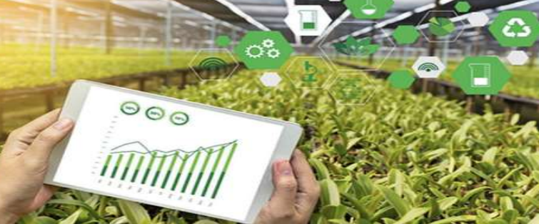 Advanced methodologies for proactive analysis gather essential information to enhance production and implement corrective measures. Smart agriculture strategies empower farmers to maximize yield and soil fertility through timely and precise interventions tailored to specific crop needs.

**c) Enhancing Decision-Making:**

AI enriches decision-making processes in agriculture by analyzing extensive data on digital platforms. Automation streamlines tasks like historical weather trend assimilation, guiding farmers on crop rotation, profitability, efficiency, and sustainability.

**d) Sustainable Farming and Efficient Water Management:**

AI and automation analyze soil fertility, historical weather data, and seed quality to inform decisions about water usage. This technology minimizes water wastage, boosts yields, and revolutionizes water management in agriculture.

**e) Agricultural Chatbots:**

AI-powered chatbots engage in personalized communication, offering farmers solutions to queries, advice, and crop-related insights. They streamline user interactions and address previously unmet needs in agriculture.

**2.2.2 The Emergence of Robotics in Precision Farming:**

The definition of an "agricultural robot" or "Agrobot" lacks consensus and formal acknowledgment within the agricultural sector. Lowenberg-DeBoer describes it as an autonomous, mobile, mechatronic entity capable of executing various crop production tasks autonomously, such as seeding, weeding, and harvesting, under human supervision. Conversely, Bechar and Vigneault classify agricultural robots as programmable machines with perceptual abilities, capable of performing diverse farming tasks including cultivation, spraying, and selective harvesting. Despite the lack of a precise definition, Agrobots represent autonomous machines proficient in executing a range of repetitive agricultural duties, from soil preparation to harvesting, without immediate human intervention. While the commercial deployment of agricultural robots remains limited, there is anticipation for increased availability and broader adoption in the future.

**2.2.3 Applications of Robotics in Agriculture:**

Agricultural robots offer a diverse array of capabilities, primarily focusing on tasks such as weed eradication, pest and disease surveillance, and specialized crop harvesting. By adopting agricultural robots, farmers can potentially reduce labor demands, minimize input consumption, and mitigate yield losses attributed to delayed pest and disease identification.

The role of agricultural robots extends beyond these core functions, encompassing various sectors where both robots and AI-based systems can find application. These technology-driven tools play a pivotal role in addressing imminent food crises and meeting future food demands. While agricultural robots have primarily penetrated developed nations, their potential impact extends to developing countries, presenting a range of opportunities across multiple domains:

**a) Cultivation of Crops:**

Agricultural robots play a significant role in planting, particularly in nurseries where seeds are nurtured into young plants, facilitating the cultivation of various vegetables, crops, and flora.

**b) Targeted Application of Pesticides:**

Excessive pesticide use poses environmental risks, but robotic and AI advancements offer targeted solutions. Drones equipped with sensors and GPS enable accurate pesticide spraying, while autonomous rovers with cameras and actuators identify pests for precise pesticide targeting.

**c) Precision Weed Management Robotics:**

Weed removal is a laborious process, prompting exploration into automation solutions. AI-powered robots equipped with sensors and actuators can revolutionize this task by discerning between crops and weeds and enabling precise weed identification and removal.

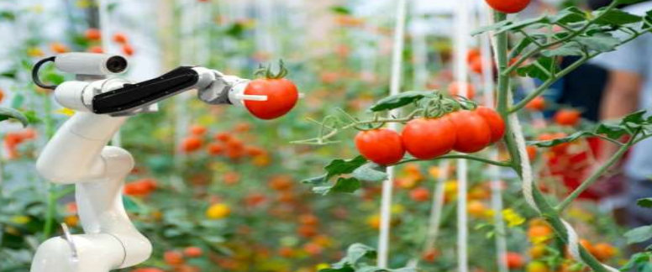**d) Automated Harvesting through Robotics:**

Harvesting remains labor-intensive, prompting the development of harvesting robots utilizing robotic arms and image recognition for locating and collecting fruits. Ongoing research focuses on creating robots capable of identifying ripe fruits and harvesting them without causing damage.

**e) Robotic Seeding Innovations:**

Robotic seeders have been developed employing methods such as reciprocal cell plates, yielding higher efficiency and minimal seeding errors, particularly beneficial for greenhouses with high plant density.

**f) Enhanced Crop Surveillance:**

Utilizing sensors and imaging technologies, farmers can optimize yield and minimize crop losses. Drones equipped with high-definition cameras facilitate disease, pest, and nutrient deficiency detection, offering unparalleled precision compared to satellite-based inspections.

**2.2.4 The Integration of Artificial Intelligence and Robotics in Agriculture:**

The fusion of artificial intelligence (AI) and robotics in agriculture heralds a transformative era, enhancing crop output and facilitating real-time monitoring across various agricultural processes. Advanced computer systems are being developed to detect plant diseases, identify weeds, predict yields, monitor crop growth, and assess yield quality. Recognizing the diverse nature of agriculture, a one-size-fits-all approach is not feasible. Intelligent agriculture revolves around automated decision-making, aiming to optimize resource efficiency, product quality, ecological balance, cost reduction, market expansion, profitability, and workforce sustainability. Robotics and AI systems support agricultural tasks, anticipate future outputs, and guide subsequent actions using digital agriculture techniques. Precision farming and robotics reduce agrochemical and fertilizer usage through precise application, potentially revolutionizing labor productivity by overcoming human limitations, especially in challenging conditions. Automation addresses gaps in both year-round and seasonal labor availability, ultimately enhancing agricultural output. It's crucial to tailor AI and robotics solutions to address the dynamic challenges of the agricultural sector.

**2.2.5 Examples of AI and Robotics Applications in Agriculture:**

**a) Dino:** The Crop-Weeding Robot Naïo Technologies (France) developed Dino, a specialized robot designed for mechanical weeding of vegetable crops. Utilizing AI in image recognition, Dino distinguishes between cultivated plants and weeds within crop rows. This mechanical weeding approach reduces herbicide-related expenses and risks while enhancing efficiency by reducing labor costs.

**b) Plantix App:** The Plantix app, developed by PEAT, a horticultural tech startup based in Berlin, facilitates plant disease identification through image matching with its extensive database. Beyond disease recognition, the app offers mitigation strategies and insights for averting future harvest infections, serving as a practical resource accessible to farmers.

**c) Blue River Technology:** Blue River Technology, a Californian startup, integrates AI, computer vision, and robotics to engineer agricultural machinery that optimizes chemical usage and expenses. Their See & Spray robot utilizes computer vision to accurately spray weeds afflicting cotton plants, mitigating herbicide resistance and ensuring precision treatment while safeguarding plant surroundings.

**3.Conclusion:**

In summary, the fusion of AI and robotics within precision agriculture marks a pivotal moment in modern farming, addressing limitations in yield, resource utilization, and environmental sustainability. By harnessing AI's analytical prowess and robotics' operational flexibility, farmers gain access to real-time, data-driven insights and precise intervention capabilities, advancing sustainable practices through optimized resource allocation and minimized environmental impact. Overcoming challenges such as technical complexities, adoption barriers, and ethical considerations will require collaborative efforts among stakeholders. Despite these hurdles, the potential benefits are substantial, offering a vision of agriculture reshaped by AI and robotics, fostering not only increased productivity but also a more harmonious relationship with our planet.

**References:**

Aktar, M. W., SenGupta, D., & Chowdhury, A. (2009). "Impact of pesticides use in agriculture: Their benefits and hazards." Interdisciplinary Toxicology, 2(1), 1–12.

Ampatzidis, Y., De Bellis, L., & Luvisi, A. (2017). "Pathology: Robotic applications and management of plants and plant diseases." Sustainability, 9(6), 1–14.

"Precision farming: The future of Indian agriculture." Journal of Applied Biology and Biotechnology, 4(6), 68–72

Lowenberg-DeBoer, J., Huang, I.Y., Grigoriadis, V. & Blackmore, S. (2019). "Economics of robots and automation in field crop production." Precision Agriculture, 21: 278–299.